UPDATE
Michigan Judicial Institute
Michigan Association of District Court Magistrates
Hotel Indigo
September15, 2017
By Peter Stathakis
MJI Program Manager

Activity 2016-2017
-18 New Magistrates participated in the certification process
-Presently have 7 New Magistrates going through the process

Thank you to MADCM members who help plan and deliver the New Magistrate seminar:
Yvonna Abraham
Dena Altheide
Robert Clark
Dennis Hall (Ret.)
Ted Johnson
Krista Krause
Kevin McKay
Jim Pahl
Millicent Sherman

As well as the agency representatives:
Lee Ann Gaspar-SOS
Jason Haines-DNR
Lance Cook-MSP

Also, thank you to MADCM for continuing to sponsor the “New Magistrate Dinner” which provides a great opportunity for new magistrates to informally interact with each other and with members of the Association.

I also want to acknowledge those magistrate instructors who volunteer to have new magistrates visit with them for a day to sit in on informal hearings. The certification process would not be complete without the following individuals:

Ms. Jeanine Blakely
Mr. Steven Brunink
Mr. Don Chisholm
Mr. Robert J. Clark
Ms. Emily DeSalvo
Ms. Janice Doner
Ms. Andra (Dudley) Richardson
Ms. Corajean Gregory
Mr. Craig A. Hess
Mr. Vern Helder
Ms. Eman H. Jajonie-Daman
Mr. Ted Johnson
Mr. Ken Knowlton
Ms. Charity Mason
Mr. Michael Milroy
Mr. Mark W. Nelson
Ms. Tammi Rodgers
Mr. Don Rivard
Ms. Robin Dillard-Russaw
Ms. Liz Stankewitz
Ms. Sandra Strauss
Ms. Jessica Testolin
Mr. A. Thomas Truesdell

MJI is always in need of experienced magistrates to act as instructors for the one-day visitation. During this visitation, the experienced magistrate meets with the new magistrate to review the process for conducting civil infraction hearings in traffic matters and demonstrates conduct of hearings. It is a commitment of zero to several days per year. If you are an experienced magistrate interested in acting as a magistrate instructor, please let me know.

-Magistrate Specialty Seminar was held August 3. Topics consisted of presentations on
Statutory, Court Rule, and Caselaw Update
Medical Marihuana/DRE Update
Implicit Bias
CMV Drugged Driving Strategies
Roundabouts—An Education Campaign

The seminar was generally well-received, but attendance was down from previous years. I am not sure if it was the date (early August) or the topics, but I would like to receive your feedback.

Other Activities

Website https://mjieducation.mi.gov/

MJI launched a new website in March, 2016 and it is regularly updated with upcoming events, items of interest, videos and publications updates.

Publications
Benchbooks: All MJI publications were updated last week and are current through September 1. I encourage you to review any benchbooks of interest, as well as the Manual for District Court Magistrates. All publications are available in HTML or PDF formats
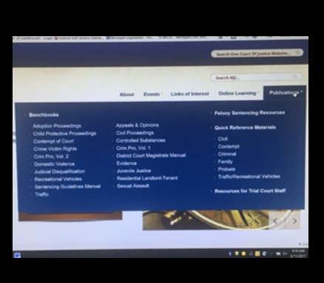

Quick Reference Materials Under the Publications tab as well, includes a section on traffic/recreational vehicles

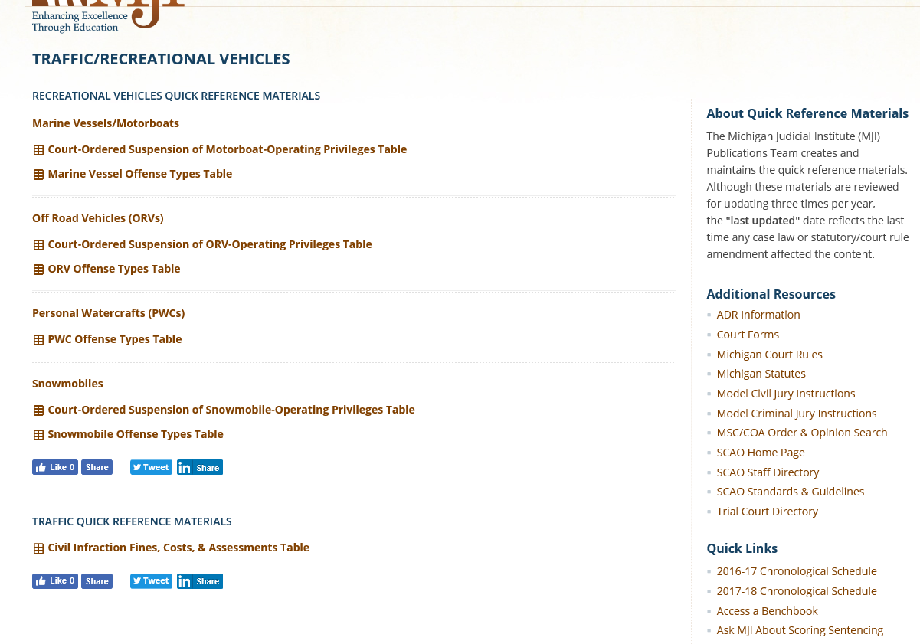

Finally
I would like to join MADCM in thanking the Michigan Office of Highway Safety Planning (OHSP) for providing funding to help support this conference, as well as some partial scholarships. We look forward to continuing our collaboration with OHSP in the upcoming year.

Upcoming MJI Magistrate-related activities for 2018
-New Magistrate seminar-March 13-15
-Magistrate Specialty Seminar-Tentatively scheduled for July 26
-Manual for District Court Magistrates—will be updaed in the Spring, 2018
-Benchbooks updated 3 times per year

Input
I want to hear from you. If you are intersted in becoming a Magistrate Instructor or have ideas for MJI magistrate training, please contact me at stathakisp@courts.mi.gov or 517-373-7607

