Year Statistics overview:
Provided by the MSP Traffic Crash Reporting System
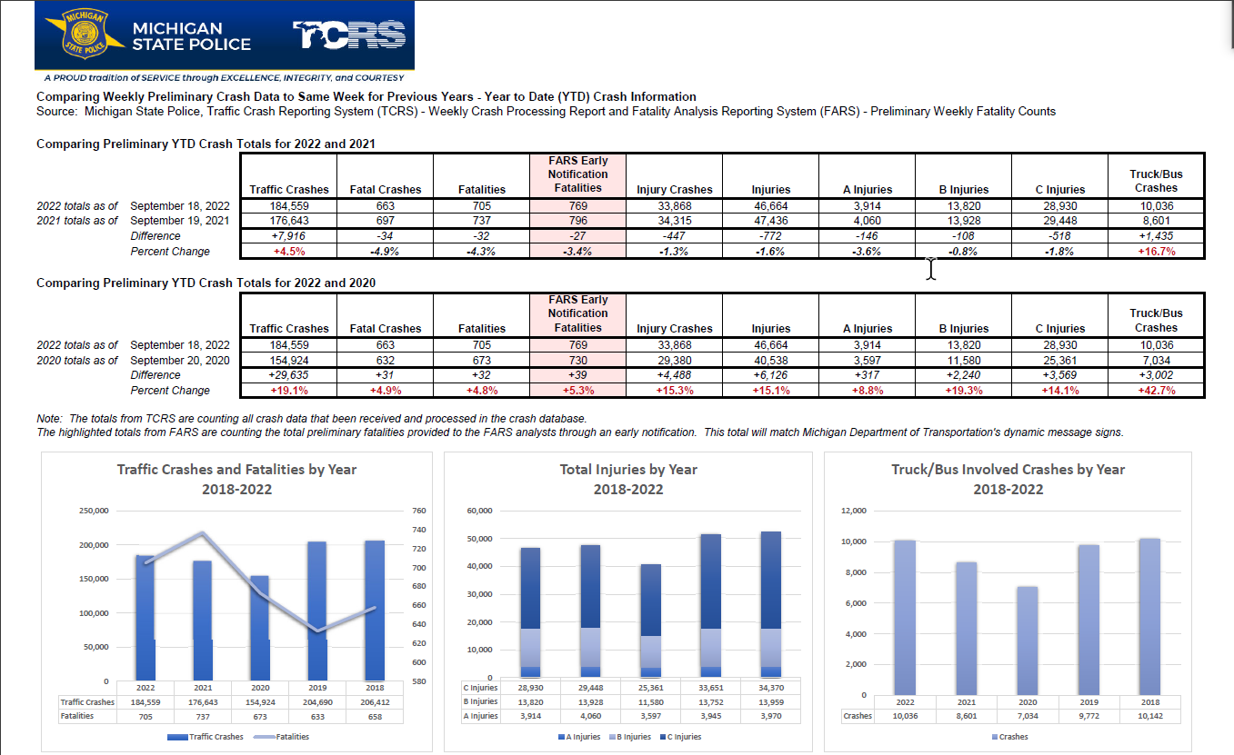
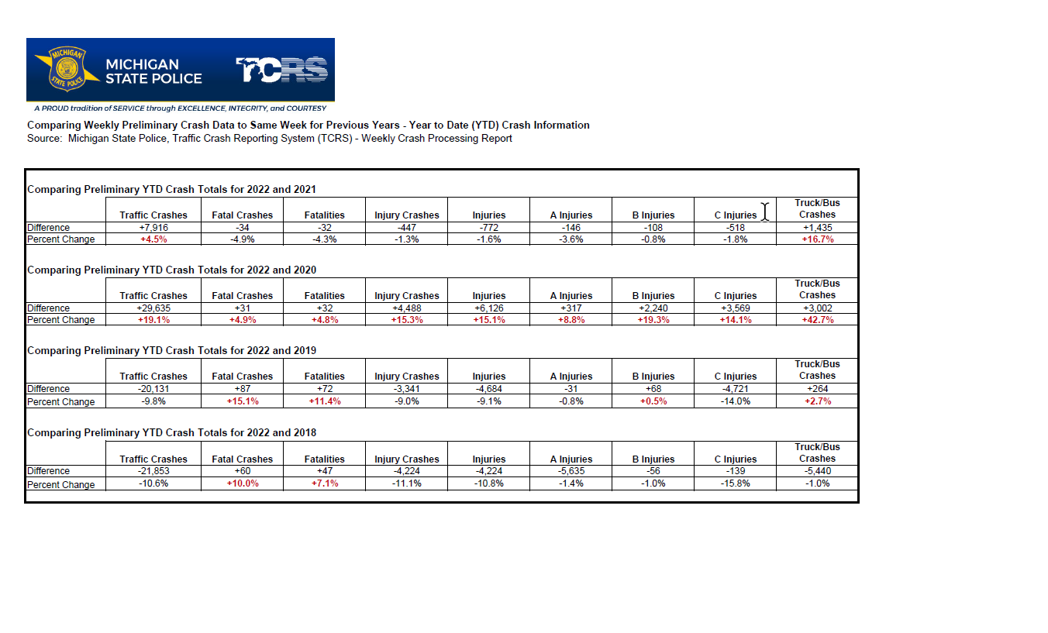Michigan Traffic Crash Facts
Traffic Crash Publications

Governor's Traffic Safety Advisory Commission (michigan.gov)
GTSAC Meetings Calendar
Action Team Meetings Notifications Location

Traffic Safety Partners (michigan.gov)
Michigan Truck Safety Commission
Traffic Safety Network
Strive for a Safer Drive S4SD)

Strive for a Safer Drive (S4SD)
Applications are now being accepted for the 2022-23 school year. All Michigan high schools have the opportunity to receive $1,000 to create a traffic safety campaign at their school. This program is sponsored by OHSP and the Ford Fund. The deadline to apply is November 14, 2022. Please contact the program coordinator at strive4asaferdrive@gmail.com with any questions. You can learn more about the program at www.Michigan.gov/S4SD.

Michigan’s Guide for Aging Drivers
Michigan’s Guide for Aging Drivers and their families is available on the Safe Drivers Smart Options (SDSO) website. This is a free guidebook that may be useful to district court magistrates. Please visit the Safe Drivers Smart Options website to order this resource at www.Michigan.gov/agingdriver. SDSO provides resources for older drivers, their families, and the professionals who care for them. Helping maintain lifelong safe mobility is everyone's responsibility, including aging adults, families and friends, and professionals who interact with aging adults.

OHSP FY23 RFP Pedestrian and Bicyclist Adjudication Education Project was posted earlier this year and the OHSP team is currently reviewing bids.

Brief project description:
The Office of Highway Safety Planning (OHSP) disseminated a request for proposal (RFP) for a multi-year project. The project goal for this first year is to obtain, analyze pedestrian and bicyclist adjudication data and provide the results to local law officials such as magistrates and prosecutors as well as the public. Years 2-4 of the project will be used to provide in-depth training and educational resources with current adjudication partners based on the data results. Year 5 of the project will be an in-depth analysis of training and data.

Child Passenger Safety
Child Passenger Safety Week runs from September 18 – 24, ending with Seat Check Saturday. This week focuses on providing caregivers with additional information on how to keep children restrained properly in a vehicle. This is a perfect time to make sure children are in the right car seat and that it is installed correctly. Visit www.michigan.gov/carseats for more information on child passenger safety, including free materials published by the Office of Highway Safety Planning.

Drug Recognition Expert
The second week of the 12th DRE School is finishing up in Auburn Hills this week for their classroom portion. There are 18 law enforcement officers in the training with 4 prosecutors auditing.
The law enforcement officers will travel to Jackson, FL October 16-23 for the field certification portion.

Overtime Traffic Enforcement
Required enforcement periods will include:
- December 1, 2022 – February 28, 2023 (speed enforcement)
- December 16, 2022 – January 1, 2023 (impaired driving enforcement)
- May 15 – June 4, 2023 (seatbelt enforcement)
- July 1 – 30, 2023 (impaired driving, seat belt, and speed enforcement)
- August 10 – September 4, 2023 (impaired driving enforcement)
Elective enforcement periods will include:
- November 21 – 27, 2022 (impaired driving enforcement)
- April 1 – 30, 2023 distracted driving enforcement)
(enclosed map and calendar in PDF)

